**Aim:**

To incorporate the various Attribution Modeling and Budget Optimization techniques and to choose the best model amongst the various models based on the ROI generated.

**Attribution Models:**

* Last Touch Attribution (LTA)
* First Touch Attribution (FTA)
* Linear Attribution
* Time Decay Attribution
* U-Shaped/Position Based Attribution

**Last Touch Attribution (LTA):**

Last touch attribution is the last of the single touchpoint attribution models. The entire credit is assigned to the last marketing touchpoint.

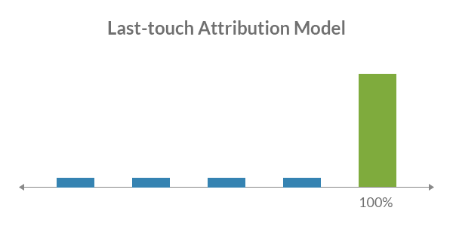

**Results**:

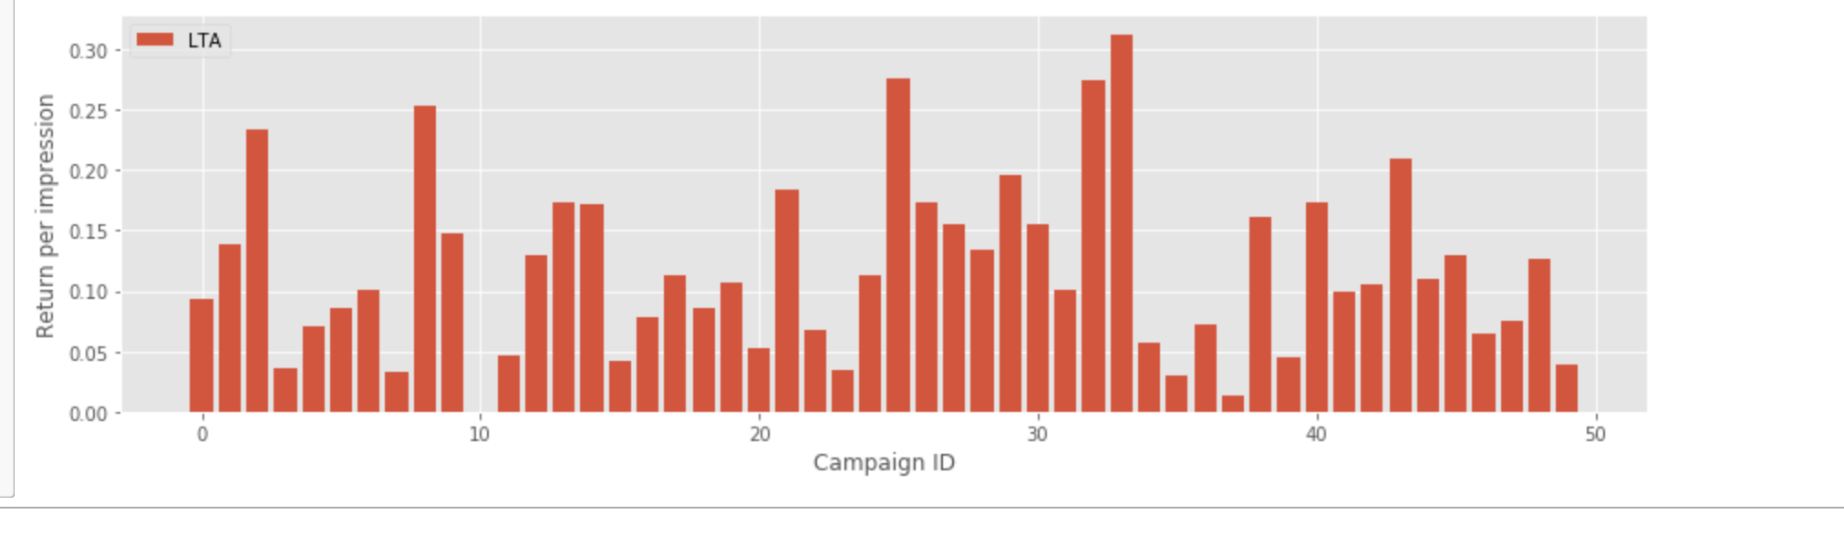

**First Touch Attribution (FTA) :**

First touch attribution is the first of the single touchpoint attribution models. The entire credit is assigned to the first marketing touchpoint.

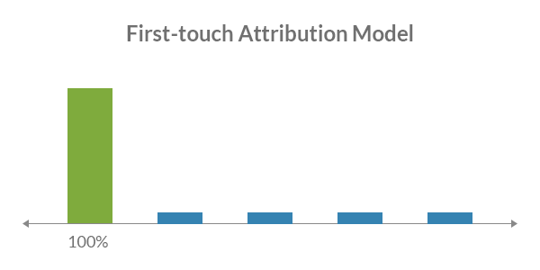

**Results:**

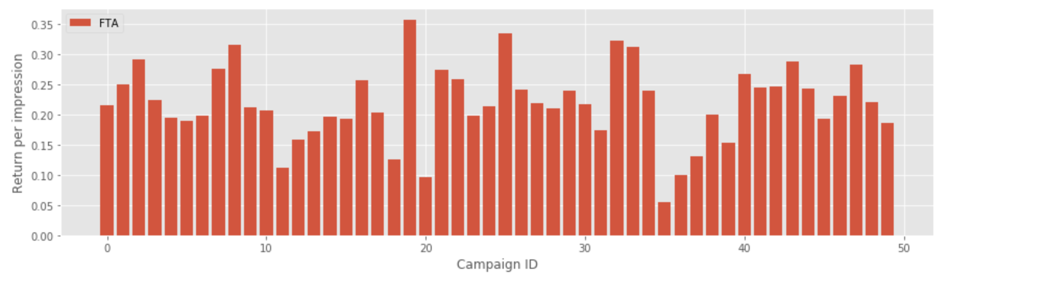

**Linear Attribution Model:**

In linear attribution model, for a conversion, the credit is split equally between all the interactions the customer had with the business.

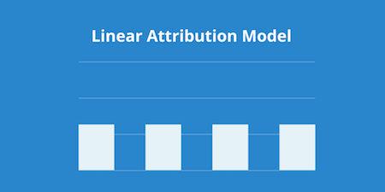

**Result:**

**U-Shaped/Position Based Attribution Model:**

The Position Based attribution model (also called U-shaped attribution) splits the credit for a sale between a prospect's first interaction with your brand and the moment they convert to a lead.

40% of the credit is given to each of these points, with the remaining 20% spread out between any other interactions that happened in the middle.

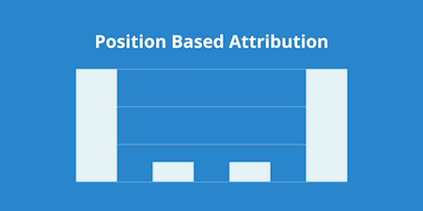

**Results:**

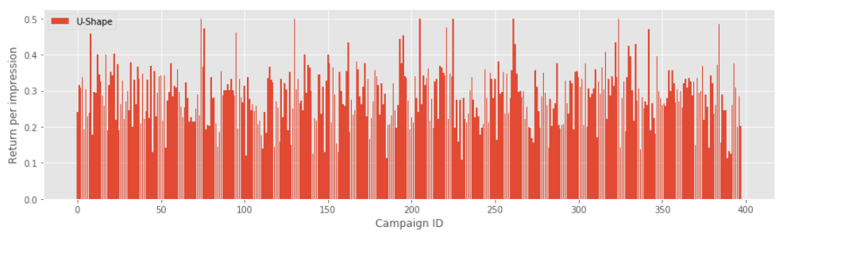

**Time Decay Attribution Model:**

Time Decay attribution is similar to Linear attribution - it spreads out the value across multiple events. But unlike Linear attribution, the Time Decay model also takes into consideration when the touchpoint occurred.

Interactions that occur closer to the time of purchase have more value attributed to them. The first interaction gets less credit, while the last interaction will get the most.

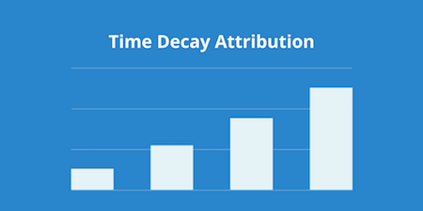

**Results:**

